ASHAPURA METAL INDUSTRIES

Cell No. - 022-6743 8344 REGD ADDRESS: - office no.5, 2nd floor, 3/5 Nagu Kamathi bulg,
E-mail – ashapurametal36@gmail.com 1st Kumbharwada Lane Mumbai-400004, Maharashtra

To,

Purchase Manager Dear Sir,

REF.: COMPANY PROFILE

COMPANY NAME | ASHAPURA METAL INDUSTRIES
ADDRESS | office no.5, 2nd floor, 3/5 Nagu Kamathi building  1st Kumbharwada lane , mumbai-400004, Maharashtra

We are taking this opportunity with great pleasure to introduce ourselves that we are one of the STOCKIESTS & SUPPILERS OF Industries Raw Materials as per details given below:

- STAINLESS STEEL: Tubes, Pipes, Plates, Bush, Pipe Fittings (Blend Reducer Tee, Union Flanges) ERW Seamless Pipe, Plates, Sheet, Coil, Strips, Flate, Circle, Electrodes,
Welding Rods, Round Hex, Wire as per AISI – 202, 304, 304L, 304H, 316, 316L, 316TI, 317, 317L, 309, 310, 321, 410, 416, & 430 etc. as per size and
Specification.
- OTHER ITEMS :Nickel, Monal, Inconel, Inconally, Hastrollys, Copper, Brass, Aluminums,
Carbon Steel, Gun Metal, ENSeries, M.S. in the from of Tubes, Pipes, Sheets, Plates, Rod, Wire, Fittings Etc
As we know that you are purchasing the above items for your plant regularly from the open market, we have decided to REGISTER our name as our approved suppliers. Hence we request you to send us your requirement from time, also have the privilege of supplying raw materials under THIRD PARTY INSPECTION.

We assure you that we can supply the material strictly as per your required specifications at the must competitive rates with necessary
TEST CERTIFICATES

1. Trade Name, if any ASHAPURA METAL INDUSTRIES

2. Constitution of Business Proprietorship

3. Period of Validity From 02/07/2018 To NA

4. Type of Registration Regular

5. Particulars of Approving Authority Centre

Range Of Pipes & Tubes
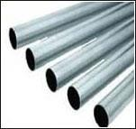
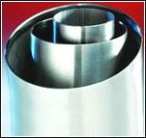
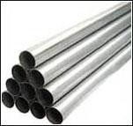

Sr. No. | Material | Size | Sch. & Swg. | Specification | Manufacturer
1. | Seamless Pipe | 15 mm NBTo  300 mm NB | Sch. 5s, 10s, 40s, 80s, 160s, XXS | A-312 | Imported, Choksi, Remi & Ratnamani
2. | Welded (ERW) Pipe | 15 mm NBTo  300 mm NB | Sch. 5s, 10, 40s & 80s | A-312 | Remi, Ratnamani, Vishal, Suraj, C.D. Prakash, Heavy, Imported Etc.
3. | Welded (ERW) Pipe | 150 mm NBTo  600 mm NB | Sch. 5s, 10s, 40s & 80s | A-358 | Fabricated at Famous, Prakash, Vishal (with Radiography)
4. | Seamless Tube | 6.35 mm OD To  101.6 mm OD | 20 Swg., 18 Swg.,  16 Swg., 14 Swg.,  12 Swg., 10 Swg. | A-213 | Ratnamani & Imported

Note:
Stainless Steel in Grade | : | TP 304, 304H, 304L, 304LN, 316, 316H, 316L, 316LN, 316Ti, 309, 310, 317L, 321, 347, 409, 410, 420, 430, 446, 202 Etc.
Special Tube & Pipes | : | Precision Tubes, Capillary Tube, Fabricated Pipe (with radiography)
In Form of | : | Round, Square, Rectangle, Oval, Coil, Flexible Pipe, Shaft, 'U' Shape, Hydraulic Tube etc.
In Length of | : | Standard length & In Cut length also.
Other Services | : | Draw & Expansion as per required Size & Length, Polish (Electro & Commercial) Heat Treatment, Bending, Anneling & Pickled, Sa nd Blasting, Machining Etc.
Test Certificate | : | Manufacturer Test Certificate / Laboratory Test Certificate from Govt. Approved Lab. / Under Third Party Inspection with Excise Gate Pass to avail Modvat benefit.
Specialize | : | § Capillary Tube, Fabricated Pipe, Square & Rectangle & Other Odd Size.  §Heat Exchanger & Condenser Tubes

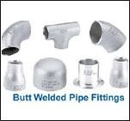

1. | Seamless | 15 NB  To  300 NB | Sch. 5 to  Sch. XXs | A-403 B/W ANSI B16.9 | § Bend (Long & Short) R=2D,3D,5D,10D Etc  § Elbow ( 180o, 90o & 45o)  § Tee (Equal & Unequal)  § Reducer (Con & Ecc)  § CAP  § Stubend (Long & Short)  § Nipple (Barrel)
2. | Welded (ERW) | 15 NB  To  600 NB | Sch. 5 To  Sch. 80s | A-403 B/W ANSI B16.9

Range of Buttweld [B/W] Fitting

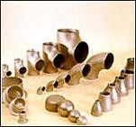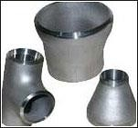

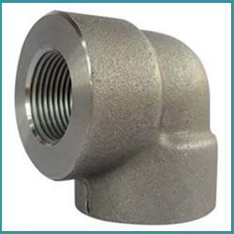
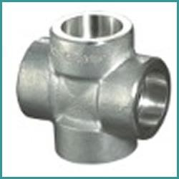
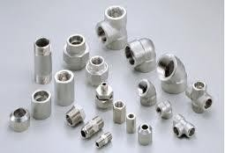
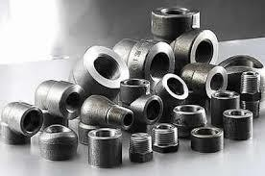
Range of Forged Fitting

Note :
Sr. No. | Material | Size | Class | Specification | Item
1. | Forged Fittings | 15 NB  To  100 NB | 3000  6000  &  9000 LBS | A-182,  ANSI B16.11 S/W, & SCRD  (As per Gauge) (NPT / BSP / BSPT) | § Elbow - 90o & 45o  § Tee - Equal & Reducing  § Union  § Cross  § Coupling - Full, Half & Quick Release  § Socket (Reducing)  § CAP  § Plug-Hex & Square,  § Nipples (Hex/Reducing)  § Bushing  § Sokolet, Weldolet, Thredolet, Elbolet & Nipolet

Range of Flanges

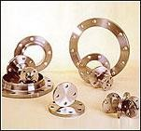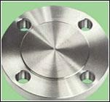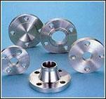
Note :

Sr. No. | Material | Size | Class | Specification | Item
1. | Forged Flange | 15 NB  To  750 NB | 150, 300, 600, 900  & 1500 LBS | A-182 ANSI B16.5 | Flanges, SORF, WNRF, BLRF, SWRF, LAP Joint,  Threaded, Reducing
2. | Plate Flange | 15 NB  To  500 NB | ASA 150, 300  Table D, E, F, H, DIN, ND-6, 10, 16, 25, 40 | A-240, ANSI B16.5 | SORF, BLRF, LAP Joint  & Spectacle

Note:
Stainless Steel in Grade | ASTM A 403 WP | : | 304, 304L, 304H, 316, 316L, 316LN, 316Ti, 309, 310S, 317L, 321, 347, 410, 420, 446, 202 Etc.
Stainless Steel in Grade | ASTM A 182 F | : | 304, 304L, 304H, 316, 316L, 316LN, 316Ti, 309, 310S, 317L, 321, 347, 410, 420, 440C, 202 Etc.
Other Forms |  | : | Compression Fitting / Instrumentation / Hydraulic Fitting / Dairy Fitting & Also As Per Drawing :
Test Certificate |  | : | Manufacturer Test Certificate / Under Third Party Inspection & with Excise Gate Pass to avail Modvat benefit.
Specialize |  | : | Long Bend with Radius - R = 3D, 5D & 10D Pigabble Bend & As per your drawing

Range of Bar (Rod) & Wire

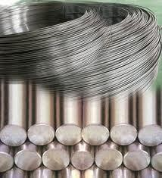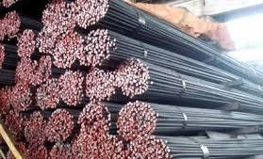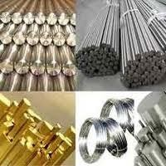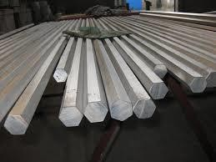

Sr. No. | Material | Diameter | Length | Specification | Manufacturer
1. | Stainless Steel Bars & Forged | 0.5 mm To  500 mm | 50 mm To  6000 mm long | A-479 | Mukund, Shah Alloys, Faker, Panchmahals, Chadan, Viraj, Bhansali & Imported

Note:
Stainless Steel (SS) in Grade | : | 304, 304L, 304H, 316, 316L, 316LN, 316Ti, 309, 310S, 317L, 321, 347, 409, 410, 420,430, 440A, 440B, 440C, 446, 202 Etc.
Other Special Grade | : | Duplex Steel (2507, 2205, 329L), Stainless Steel 17-4 PH (630 Gr.) 15.5 PH, 17.7 PH, 4122 Etc.
Bar Finishing | : | Bright, Polish & Black
Bar in Form of | : | Round, Square, Hex (A/F), Rectangle, Wire (Coil Form), Wiremesh, Billet, Ingot, Forging Etc.
Hardness for Wire | : | Soft, Hard, Half Hard Etc.
Other Services | : | Machining (CNC), Centreless Grinding (CG), Heat Treatment, Anneling, Pickling, Polish, Rolling, Forging, Cutting, Bending, Minor Fabrication,
Test Certificate | : | Manufacturer Test Certificate / Laboratory Test Certificate from Govt. Approved Lab / Under Third Party Inspection & with Excise Gate Pass to avail Modvat benefit.
Specialize | : | 440C, CG, Forging, Wiremesh etc

Range of Sheet, Plate, Strip, Flat & Blank

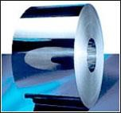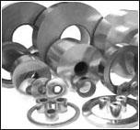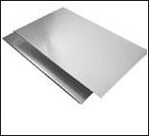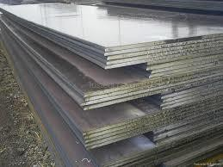

Sr. No. | Material | Size | Thickness | Specification | Manufacturer
1. | Stainless Steel | 1000 mm x 2000 mm  1220 mm x 2440 mm (4' x 8')  1250 mm x 2500 mm  1500 mm x 3000 To 6000 mm  2000 mm x 4000 To 6000 mm | 0.3 mm To  120 mm | A-240 | Jindal, Sail, Shah Alloys, Imported Etc.

Note:
Stainless Steel (SS) in Grade | : | 304, 304L, 304H, 316, 316L, 316LN, 316Ti, 309,  310S, 317L, 321, 347, 409, 410, 420, 430, 446, 202 Etc.
Sheet Finishing | : | 2B, 2D, HR, CR, BA (No. 8), Satin (Met with Plastic Coated)
Sheet & Plate in Form of | : | Coils, Foils, Shim Sheet, Perforated Sheet,  Chequered Plate, Strip, Flats, Blank (Circle), Ring (Flange) & Angle, Channel, Tray Etc.
Other Services | : | Heat Treatment, Anneling, Pickling, Polish, Electroplating, Anodising, Rolling, Cutting, Bending, Forging, Minor Fabrication Etc.
Test Certificate | : | Manufacturer Test Certificate / Laboratory Test Certificate from Govt. Approved Lab. & Under Third Party Inspection with Excise Gate Pass to avail Modvat benefit.
Specialize | : | Shim Sheet, Perforated Sheet (Round, Square & Oblong Hole) & as per your Drawing

Fasteners

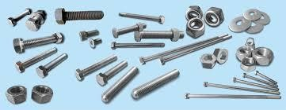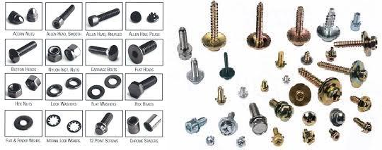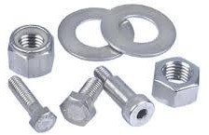

STAINLESS STEEL & MILD STEEL FASTNERS in various sizes..

Materials dealt by us are Guaranteed and we provide Mill T.C./ Govt. Approved Lab: T.C. with the Supply. Third party Inspections by any reputed Organizations like The Lloyds, EIL, PDIL, BVIS, DNV Etc. is accepted by us.
We maintain good bulk stock of the above Materials for catering to our esteemed Customers. Our Aim is to have long-term Customers, satisfied & trusting in our product & Services.

As we wish to Start Business with you in a Long Term Basis, may we request you to kindly enlist our firm in your vendors list and let us have your valued enquiries regularly as & when it arises.

If you require any further information, Kindly feel free to contact us, we will revert back immediately.

VALVES

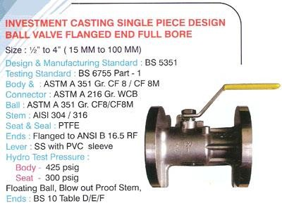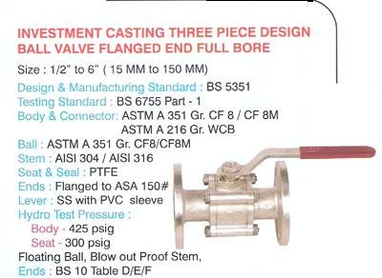

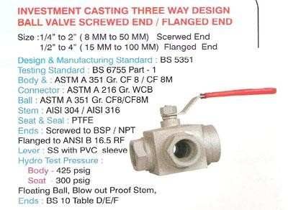

An early action in matter will be highly appreciated.

Thanking you.

E-MAIL - ashapurametal36@gmail.com / sales.ashapurametal@gmail.com

